- The following command was executed to build Docker images for both the frontend (Node.js) and backend (Flask) services and to start the containers using Docker Compose. This ensures that all services are built from their respective Dockerfiles and run together in a shared Docker network.
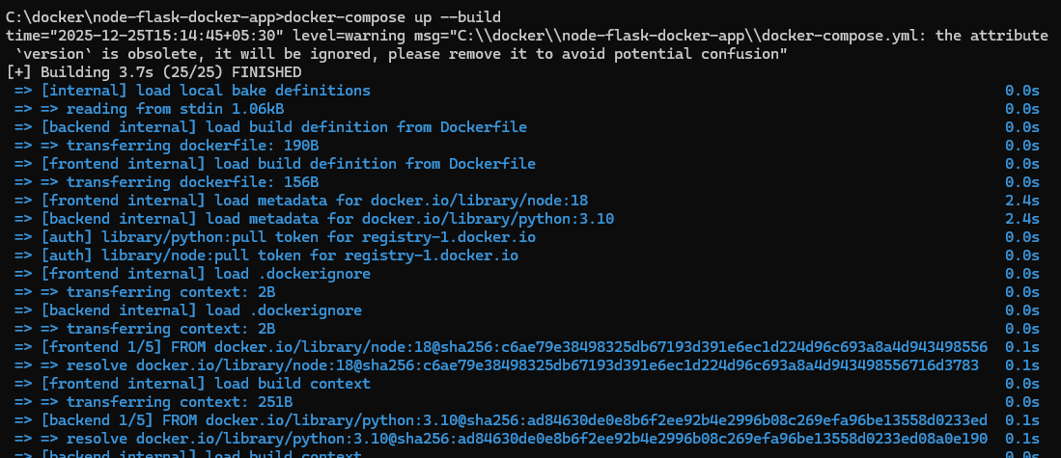
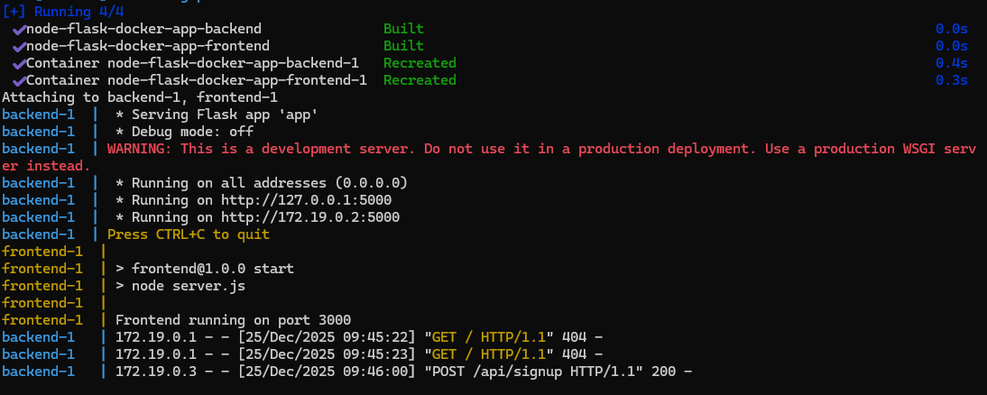
- The docker images command is used to verify that the Docker images for the frontend and backend applications were successfully created. The output confirms the image names, tags, image IDs, and sizes.
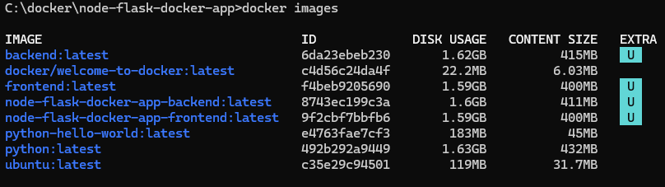
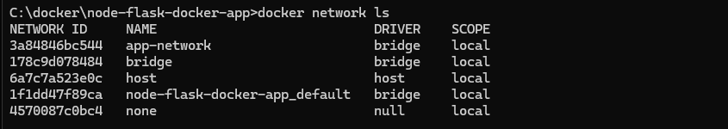
- The frontend application was successfully accessed through a web browser using localhost:3000. This confirms that the Node.js frontend container is running correctly and is able to communicate with the Flask backend service.
